**LESSON 2**

**Excretion**

Excretion is the removal of toxic (nitrogenous) waste products of metabolism from the body.

Nitrogen, which is a highly toxic end product of protein metabolism, is found in large quantities and needs to be excreted as soon as it is formed.

The term 'excretion' is correctly applied only to substances which must cross the cell membrane to leave the body. This does not include expulsion of undigested food material (egestion) since the food passes down the digestive tract without ever passing through a cell membrane

When proteins, amino acids or nucleic acids are catabolized, 3-nitrogen-containing predominant excretory end-products are formed: ammonia, urea and uric acid.

The waste end products of catabolism contain carbon, hydrogen, oxygen and nitrogen.

Carbon atoms are eliminated in carbon dioxide, hydrogen in water (H2O), and oxygen in carbon dioxide and water.

**Excretory Organs**

* Kidneys: urinary system
* the skin,
* lungs and
* liver

**Skin**

Human skin possesses glands for secreting two fluids on its surface, namely

sweat from the sweat glands and

sebum from sebaceous glands.

Sweat is a watery fluid containing sodium-chloride, lactic acid, urea, amino acids and glucose.

Sebum is a wax-like secretion which helps to excrete some lipids such as waxes, sterols, other hydrocarbons and fatty acids on the skin.

Skin therefore helps in excreting mainly water and sodium chloride, and a small amount of urea and lactic acid.

**Lungs**

* Lungs help to eliminate the entire volume of carbon dioxide produced in the body, as well as some moisture, during expiration.
* The lungs maintain the blood-gas homeostasis through elimination of carbon dioxide.
* When lungs fail to eliminate enough carbon dioxide, the kidneys attempt to compensate. By converting some of the carbon dioxide into sodium bicarbonate, which becomes part of the blood buffer system.

**Liver**

The liver is a very important organ of excretion. The liver breaks down many substances in the blood, including toxins. The liver also excretes bilirubin — a waste product of hemoglobin catabolism in bile. Bile then travels to the small intestine, and is eventually excreted in feces by the large intestine.

**Human excretory system**

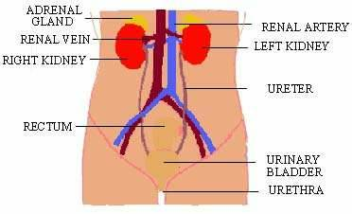

Two kidneys

* Each kidney has an outer convex surface and shows an indentation on the inner side called the hylum.
* The hylum functions as a route of entry and exit for the blood vessels, lymph vessels, nerves and ureters of the kidney
* The renal artery branching from the aorta brings oxygenated blood to the kidneys
* and the renal vein takes deoxygenated blood away to the vena cava
* The paired adrenal glands are present on top of the kidneys

Urinary bladder

* urinary bladder opens into the urethra which opens through the vagina and the penis and transports both urine and semen.
* extensible reservoir of urine
* changes it size and shape according to its contents
* It is situated behind the pubic symphysis in males, and in front of the uterus in the female.
* sphincter muscle at the mouth of bladder
* expulsion of urine from the urinary bladder is called micturition

Histology of kidney

* kidney consists of two regions, the outer dark region called the cortex, and the inner, lighter colored zone; medulla.
* It contain a large number of tiny tubules (nephrons)
* It contain many capillaries and connective tissue
* It contain a collecting space called the pelvis where the ureter leaves the kidney
* 6 to 15 cones or pyramids of kidney tissue project into the pelvis.
* The renal artery divides into capillaries which carry blood to the glomerulus of the uriniferous tubules.
* The renal vein carries blood away from the uriniferous tubules through its capillary network.

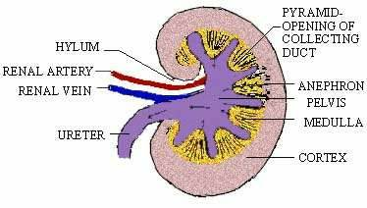

**Structure of a uriniferous tubule (Nephron)**

The nephron is the basic excretory unit of the kidney

Each nephron consists of a

* Glomerulus: The glomerulus is a small knot of blood vessels formed by a capillary network from the renal artery (afferent vessel). The glomerulus is surrounded by a cup-shaped structure called Bowman’s capsule. The Bowman’s capsule and the glomerulus together are called the Malpighian body.
* Each Bowman’s capsule leads into a renal (kidney) tubule.
* The renal tubule is made up of a first convoluted tubule, (descending and ascending tubules with a Henle’s loop in between) and a second convoluted tubule leading to a large collecting duct (also called the duct of Belini).
* The collecting duct passes through the medulla and opens into the pelvis of the kidney at the apex of a pyramid
* The Malpighian body, proximal and distal convoluted tubules lie in the cortex.
* Henle’s loop and main collecting ducts are present in the medulla.
* The proximal convoluted tubule is lined by ciliated cubical epithelial cells, the ascending limb and the distal convoluted tubule by cuboidal epithelium and the descending limb is lined by the flattened epithelial cells.
* The smaller efferent vessels take the blood away from the glomerulus and enter the capillary network around the tubule of the nephron.
* The capillaries unite to form the venules to form the renal vein which joins the inferior vena cava.

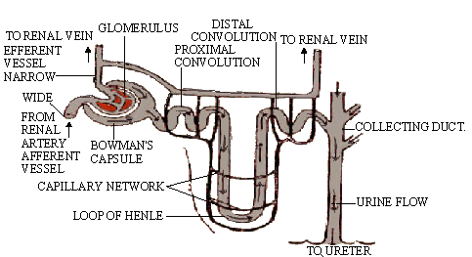

**Ureter**

ureter, conveys urine from each kidney into the urinary bladder

**Formation of urine**

The formation of urine involves three processes:

* ultrafiltration,
* reabsorption and
* Secretion

Reabsorption and secretion involve active transport, therefore are physiological processes; while ultrafiltration is a physical process (filtration under pressure).

**Ultrafiltration** is movement of water (solvent) and dissolved molecules of a small size (solutes) from malpighian body into the tubular lumen under physical pressure

This forms the primary urine or deprotenized plama which is isosmotic to blood from which it is derived.

**Process of ultrafiltration**

* The afferent vessel, which is of a larger diameter than the efferent vessel, brings the blood into the glomerulus
* The endothelial cells of blood vessels, the basement membrane and the single cell lining of the Bowman’s capsule form a semipermeable membrane.
* The blood entering the glomerulus is filtered through the semipermeable membrane into the lumen of the Bowman’s capsule under pressure.

**Reabsorption**

* The primary urine (glomerular filtrate) enters the proximal convoluted tubule where its volume is reduced by about 80%
* This is accomplished by active reabsorption of many useful substances like sodium chloride, glucose, amino acids, etc. from the tubular fluid into the blood,
* The water diffuses out of tubular fluid into surrounding tissue in a process called obligatory reabsorption of water. Thus, in proximal tubule there is a drastic reduction in fluid-volume without any change in its osmolarity (maintains osmotic balance).

**Secretion**

The secretion of unwanted substances (e.g. urea) from the blood into the tubular fluid.

These processes are regulated by certain hormones from the pituitary and adrenal gland.

* Antidiuretic Hormone (ADH) also called vasopressin is secreted from the brain When water needs to be conserved by the body, the distal convoluted tubule and collecting tubules reabsorb more water, so that urine becomes more concentrated.
* In the absence of ADH, reabsorption of water is reduced, leading to excretion of increased amounts of more dilute urine.
* Aldosterone: produced in the cortex of the adrenal gland, it helps in Reabsorption of sodium ions, Increased aldosterone production results in increased reabsorption of sodium ions, whereas lowered levels of aldosterone causes increased excretion of sodium.
* Angiotensin: In order to maintain normal blood supply and filtration pressure (autoregulation) stretch receptor cells in the juxtaglomerular apparatus of the kidney initiate nerve impulses and produce a proteolytic enzyme called renin. This enzyme causes the release of angiotensin I and II (one and two). If blood pressure or blood supply is low, angiotensin increases blood pressure by vasoconstriction  of arteries and also stimulates secretion of aldosterone.